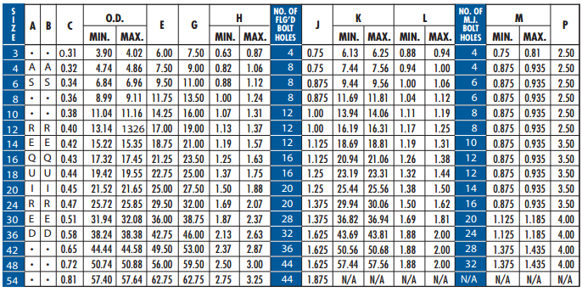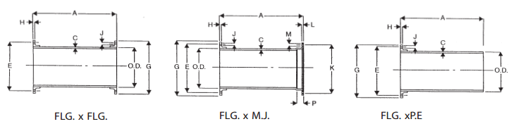

1. 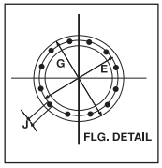Tolerance on length of FLGxFLG and FLGxMJ pipe shall be ±0.125”
2. Tolerance on length of FLGxPE shall be ±0.25”/
3. Above material shall meet all applicable selections of ANSI A21.10, A21.15, A21.51, B2.1, B16.1/AWWA, C110, C115, C150, C151, and all revisions thereto.
4. Flanged pipe shall be Ductile Iron pipe with Ductile Iron Flanges threaded on.
5. Linings, if required, shall be in accordance with ANSI A21.4
6. The Mechanical Joint bell for 30” to 36” sizes of Ductile Iron pipe have thicknesses different from those shown in ANSI A21.11, which are based on gray iron pipe. These reduced thicknesses provide a lighter-weight bell which is compatible with the wall thickness of Ductile Iron pipe.
7. Submitted material only. Consult engineer for application.
8. 250lb. faced and drilled flanges available upon request.

|  |  |
| --- | --- |
| Job name: _________________________________________  Engineer: __________________________________________  Approval: __________________________________________  Contractor: ________________________________________  Contact: ___________________________________________ | **C:\Users\salexander\Desktop\Website Content\WaterSolutions Droplet and word.jpg**  **C:\Users\salexander\Desktop\Website Content\WaterSolutions Droplet and word.jpg**  www.EverythingInsideTheFence.com |